Surface properties of glass ionomer cement after addition of Date seeds powder
Fryal Adeel, Lubna Ghalib*
Department of Materials Engineering, Mustansiriyah University, Baghdad-Iraq

Email: ebma030@uomustansiriyah.edu.iq
Corresponding Author: lubnaghalib81@uomustansiriyah.edu.iq

Abstract
The aim of this study was to investigate the effect of adding date seeds powder to the glass ionomer cement on surface roughness, water sorption, and wettability. A conventional glass ionomer powder was mixed with date seed powders in different amounts. Mix 1, 3, and 5% (w/w) date seed powder with the glass ionomer powder by hand for 2 minutes. The samples were immersed in an artificial saliva solution during one-day, one-week, and one-month test periods. After 30 days, the surface roughness Ra values of the samples were found to be higher. After a month, water absorption decreased among the tested samples. In the wettability test, all of the samples were found to be hydrophilic and have a contact angle of less than 90 degrees. But all of the specimens are very close to being water-resistant.
Keywords: Glass ionomer cement, dates seed, Surface roughness, water sorption, wettability.
Introduction
An increase in the demand for improved esthetics and the fluoride releasing ability of restorative materials has resulted in the development and widespread use of tooth colored restorative materials in pediatric dentistry.
One such material, a glass ionomer cement (GIC), has been advocated for use because of various reasons, including its physical–chemical bonding to the tooth structure, acceptable esthetic properties, biocompatibility, continuous fluoride release to the adjacent structures over a long period, inhibition of bacterial acid metabolism and activity, similar coefficients of thermal expansion to that of the tooth structure, and ease of clinical application [1-3]. However, conventional GICs also have a number of drawbacks, such as dehydration, initial moisture sensitivity, a prolonged setting reaction time, and a rough surface texture, which can negatively affect the mechanical properties of the restoration and lead to clinical failure [4, 5].
In order to fix these problems, different types of glass ionomer-based restorative materials and different types of glass ionomer-based material formulations have been made. These materials are easier to work with, last longer, and look better [6, 7]. Some of these are high-viscosity glass ionomers, resin-modified glass ionomer cements (RMGICs), and polyacid-modified composite resins (PMCRs). The newest innovations are based on nanotechnology and include high-viscosity GICs that set faster and have nanofluoroapatite/hydroxyapatite particles in them, as well as GICs that have been modified with resin [8, 9]. By adding nano-sized filler particles to glass ionomer-based materials, their mechanical properties, resistance to wear, color stability, and resistance to biomechanical degradation may be improved.
Although a few studies of nano-filled GICs have been performed, given the increasing use of GICs and recent trends toward increased consumption of acidic beverages, additional research is needed on the effects of these beverages on the surface texture of GICs. The clinical success of restorations depends on their long term durability in the oral environment. Thus, information is also needed on the performance of GICs as a restorative material.
Also, there are different kinds of surfaces in the mouth (enamel, restorative materials, and implants, orthodontic and prosthodontic appliances). When figuring out how wet the oral substrate is, the contact angle of saliva, artificial saliva, and different mouthwash solutions on enamel, glass ionomer cement, composite material, and other materials should be measured. The way wettability is interpreted can give information about how the surfaces of the mouth interact with liquids that are commonly used [10, 11]. Therefore, the purpose of this study was to evaluate the effects of the addition of 1, 3 and 5 wt. % of Date seeds powder micro particles size into conventional GIC on the surface properties immersed in artificial saliva solution.
Materials:
The seeds were washed with clean water and then left out in the open air for 24 hours to dry. The dried seeds were heated in an oven at 70°C for 24 hours to get rid of the water. After that, the seeds were crushed and milled for 5 hours using a high-speed multi-functional crusher (rotating speed 22000 r/min). Then, the material was filtered until the target micro-scale particle size (less than 50 micro) was reached, which was confirmed by x-ray diffraction.
A conventional glass-ionomer powder (Shanghai Rongxiang Dental Material Company Ltd, China) with a particle size of about >500 µm was blended with different proportions of date seeds powders. Powders were made by mixing 1, 3 and 5% (w/w) date seeds powder with the glass ionomer powder by hand for 2 min. The unblended powder was used as the control for all tests. The recommended powder/liquid (P/L) ratio of 20 g: 15 L by weight for glass ionomer cement was used in all of the prepared specimens. The samples were stored in artificial saliva based on the formulation described by Adsul et. al.[12], for one day, one week and one month. The materials used for preparing the artificial saliva are potassium chloride, sodium chloride, monopotassium phosphate, disodium phosphate, calcium chloride, sodium thiocyanate, ammonium chloride, urea, glucose, mucin and ascorbic acid. The artificial saliva was renewed daily. Figure 1 shows the samples immersed in the artificial saliva solution.

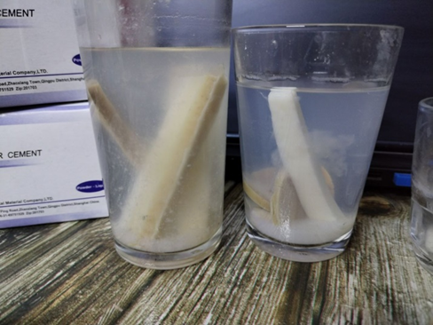
Fig.1. samples immersed in the artificial saliva

Surface properties testing
Surface roughness
A Hand-held Roughness Tester (TR200) ​​manufactured by (TIME Group Inc.) was used. Figure 2 shows the surface roughness tester used in the study. The dimensions of the Disc ‑shaped specimens are (40 mm* 10 mm). These models have proven their value in practical use for surface finish quality testing. An examination tube with a needle head (The recording needle in the cylinder and it has a tapering tip) and the surface of the material whose surface roughness is measured, and then the specific pressure is applied in that place and by moving this needle on the surface it turns within minutes into a digital reading in the device, which serves to work with it with one touch and contact with the device with the surface of the model to measure its surface roughness, provided that these materials are flat and subject to contact with the device.

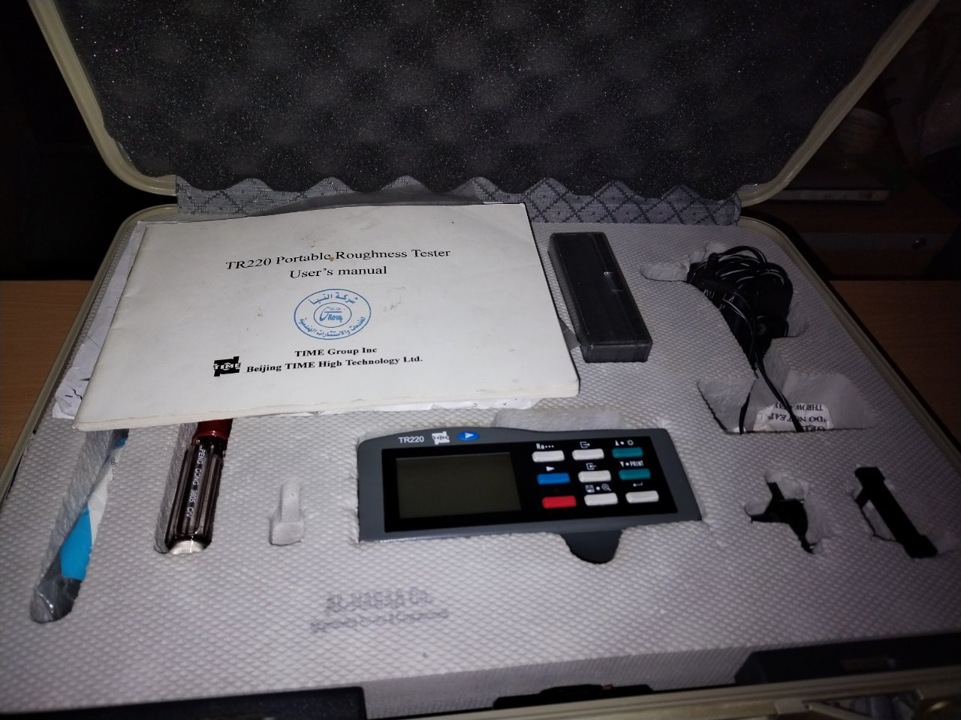
Fig.2. Surface roughness test device

Water sorption
Disc ‑shaped specimens were prepared at 37 ± 1°C for 1 hr. (d = 20 mm, h = 4 mm).Samples were weighed before immersion. Then, the specimens were stored in artificial saliva at 37 ± 1°C for 1, 7, and 30 days. After each period, the specimens were weighed using an electronic analytical balance (0.0001 mg precision). The measurements were repeated, and the baseline constant mass (m₀) was recorded. All specimens were kept in artificial saliva, and they were weighed after 1, 7, and 30 days.
Before weighing, the samples were carefully dried on filter paper until there was no visible moisture left. They were then waved in the air for 15 seconds, weighed to 0.0001 mg 1 minute later, and then put back in their containers. The mass was written down as (m₁). Using the same cycle as what was said above. After 30 days, the materials were measured to see how much water they could hold. The water absorption of the samples (W_{SP}) in (µg/mm³) was determined based on the equation below:
$$W_{SP}=\frac{m_{0}-m_{1}}{V}$$

Wettability
The contact angle measuring method can be used to figure out how wet the surfaces of specimens are. Wetting is the ability of a liquid to stay in contact with a solid surface when it comes in contact with it. By measuring the contact angle, you can see how the liquid acts on a surface made of different materials. It is used to find out how water-resistant the composite surfaces are. The tests on the samples were done based on specification ASTM D - 7334. The disc-shaped specimens are 40 mm by 10 mm. A glass pipette is used to put a drop of water on the composite surface of the device. In all composites, the size of the water droplet stayed the same. Figure 3 shows the experimental setup that is used to measure the contact angle. It has an image processor, a moveable holder, a camera, optical lenses, and test sample holders.

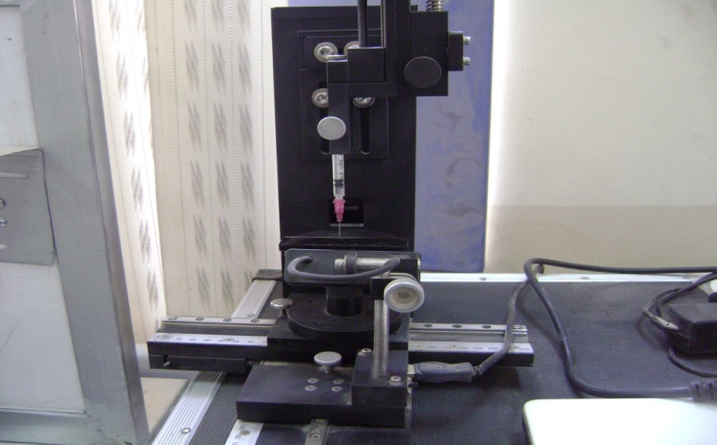
Fig.3. Wettability test device

Results and discussion
Surface Roughness
Ra values for (1, 7, and 30 days) are presented in Table 1 All the tested materials showed significantly higher Ra values compared with the pure specimen after immersion in saliva.

Table 1. Surface Roughness values (Ra) for samples
Filler addition% | 1 day Ra1 | 7 days Ra2 | 30 days Ra3
0% | 0.998 | 1.861 | 2.407
1% | 1.100 | 1.083 | 1.303
3% | 1.922 | 2.906 | 3.140
5% | 2.865 | 3.656 | 4.421

Water sorption
Table 2 shows how much water the samples that were tested took in. Most of the water was taken up by all of the samples in the first 24 hours. The amount of water that each test material could hold for 24 hours and 30 days was very different. The least amount of water was taken up by samples after 1 month. As shown in Table 2, water sorption decreases for each addition after one month.

Table 2. Water sorption values
Filler addition% | Water sorption (µg/mm³)  after 1 day | Water sorption (µg/mm³)  after 7 days | Water sorption (µg/mm³)  after 30 days
0% | 0.0906 | 0.0953 | 0.0695
1% | 0.2039 | 0.1716 | 0.1410
3% | 0.1325 | 0.1227 | 0.0946
5% | 0.3318 | 0.2785 | 0.2491

Wettability
Contact angle measure analysis can be used to estimate the wettability or hydrophilicity of a GIC sample. A device for processing images was used to figure out the contact angle. Disc-shaped specimens with DS filler of (0%, 1%, 3% and 5%) addition, and the values obtained after 1 month of immersion in artificial saliva are shown in Table 3.

Table 3. Content Angles values
Filler percentage | Contact angle value (Degree) after 1 month
0% | 75.18
1% | 78.74
3% | 81.22
5% | 88.13

In general, surfaces that are rough have the highest contact angles and surfaces that are smooth have the lowest. A surface that is hydrophilic has a contact angle that is less than 90 degrees. Hydrophobicity is shown by a slope that is greater than 90 degrees. All of the made samples had contact angles that were less than 90 degrees, which showed that they were hydrophilic, but as the filler addition increased the contact angle shows a value close to 90 degrees (5% addition has a contact angle of (88.13%). Figure 4 shows images of contact angle measurements.

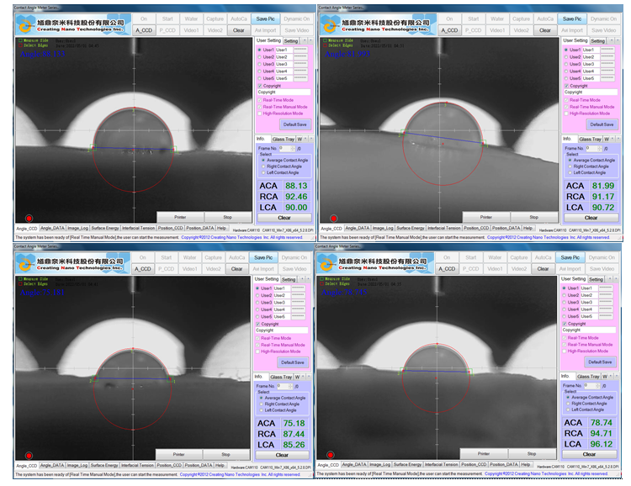

Fig.4. Wettability test values

Conclusions
Based on the obtained results, it can be concluded that the surface properties of the glass ionomer cement were enhanced by the addition of the Date seed powder microparticles. These results were expected due to the date seed behavior as compared with the control group of the glass ionomer cement sample. It was found that samples have a higher Ra value after one month. Water sorption decreases for each addition after one month. As for the wettability test, it was found that all the specimens were hydrophilic and had a contact angle below 90 degrees. But all the specimens are close to having a hydrophobic nature.

Acknowledgment
The authors would like to thank the Department of Materials Engineering – College of Engineering, Mustansiryiah University for supporting this work.

References

[1] D. P. Raggio, T. K. Tedesco, A. F. B. Calvo, and M. M. Braga, "Do glass ionomer cements prevent caries lesions in margins of restorations in primary teeth?: A systematic review and meta-analysis," The Journal of the American Dental Association, vol. 147, pp. 177-185, 2016.
[2] A. M. Saber, A. A. El-Housseiny, and N. M. Alamoudi, "Atraumatic restorative treatment and interim therapeutic restoration: a review of the literature," Dentistry journal, vol. 7, p. 28, 2019.
[3] A. S. Khan and M. R. Syed, "A review of bioceramics-based dental restorative materials," Dental Materials Journal, vol. 38, pp. 163-176, 2019.
[4] M. S. Baig and G. J. Fleming, "Conventional glass-ionomer materials: A review of the developments in glass powder, polyacid liquid and the strategies of reinforcement," Journal of Dentistry, vol. 43, pp. 897-912, 2015.
[5] A. M. Kielbassa, E. P. Oehme, N. Shakavets, and M. Wolgin, "In vitro wear of (resin-coated) high-viscosity glass ionomer cements and glass hybrid restorative systems," Journal of dentistry, vol. 105, p. 103554, 2021.
[6] V. Ehlers, K. Gran, A. Callaway, B. Azrak, and C.-P. Ernst, "One-year clinical performance of flowable bulk-fill composite vs conventional compomer restorations in primary molars," J Adhes Dent, vol. 21, pp. 247-54, 2019.
[7] N. Gonulol, S. Ozer, and E. Sen Tunc, "Water sorption, solubility, and color stability of giomer restoratives," Journal of esthetic and restorative dentistry, vol. 27, pp. 300-306, 2015.
[8] R. Babannavar and A. Shenoy, "Evaluation of shear bond strength of silorane resin to conventional, resin‐modified glass ionomers and nano‐ionomer cements," Journal of investigative and clinical dentistry, vol. 5, pp. 295-300, 2014.
[9] U. Menne-Happ and N. Ilie, "Effect of gloss and heat on the mechanical behaviour of a glass carbomer cement," Journal of dentistry, vol. 41, pp. 223-230, 2013.
[10] N. Jaiswal, P. G. Patil, A. Gangurde, and R. D. Parkhedkar, "Wettability of 3 different artificial saliva substitutes on heat-polymerized acrylic resin," The Journal of prosthetic dentistry, vol. 121, pp. 517-522, 2019.
[11] L. Guo, P. Wong, and F. Guo, "Correlation of contact angle hysteresis and hydrodynamic lubrication," Tribology Letters, vol. 58, pp. 1-9, 2015.
[12] P. S. Adsul, P. Dhawan, A. Tuli, N. Khanduri, and A. Singh, "Evaluation and Comparison of Physical Properties of Cention N with Other Restorative Materials in Artificial Saliva: An In Vitro Study," International Journal of Clinical Pediatric Dentistry, vol. 15, p. 350, 2022.

