Testing Standards for Energy Absorber of Car Bumper

1st Mustafa Kodi Mechanical Engineering
Department
Al-Nahrain University
Baghdad, Iraq
mustafakodi90@gmail.com

2nd Prof. Dr. Abdulrahman N. Abood Mechanical Engineering Department
Al-Nahrain University
Baghdad, Iraq
abdulrahman.n.abed@nahrainuniv.edu.iq
Abstract- The purpose of an automobile bumper's energy absorber is to deflect the kinetic energy of a collision-causing vehicle. This is typically achieved using a variety of materials and technologies, including crushable foam, plastic, or metal honeycomb structures, and springs or other flexible elements. The purpose of an energy absorber is to reduce the amount of force that is transmitted to the occupants of a vehicle during a collision, which can help to prevent injuries and save lives.
Keyword- Bumper energy absorber, automobile, car crashes.
- Introduction
One of the industries with the greatest growth rates worldwide is the automotive sector. One of the most crucial factors in car design nowadays is safety. In cases of crashes at slower speeds, a vehicle's bumper is crucial to the protection of pedestrians. [1]. Front and rear bumpers are automotive protection made of steel, aluminum, rubber, or plastic on a passenger car. The bumper system absorbs the shock in low-speed collisions to avoid or lessen damage to the vehicle. The rearmost or frontmost portion of an automobile is called a bumper, and it serves as a means of impact protection for the occupants within during collisions. [2]
1.2 Function of a bumper system.
A bumper system's purpose is to reduce injury or damage during rear and frontal crashes with pedestrians, other vehicles, and fixed objects at comparatively lower speeds by absorbing impact energy through elastic and plastic deformation.A car's bumpers, which are fastened to the front and rear sides of the vehicle, protect it. Due to their extensive deformation zones, they lessen the consequences of collisions with other vehicles and objects. The bumpers are designed and constructed in this manner in order to deform and absorb the force (kinetic energy) during a collision. [3]
However, a car's bumper systems should be built to absorb the force of slow-speed crashes and assist safeguard the interior and other pricey parts that are close by.[4]

1.3 Standards of Bumpers and insurrance requirements.
Most regulations stipulate that all cars must have bumpers. The height and placement of bumpers may also be legally required in accidents involving vehicles of different heights to prevent the smaller car from slipping under the larger one. More and more bumpers are being produced to decrease the damage that cars cause to pedestrians, such as by using bumper covers made of flexible materials. Nevertheless, bumpers can't prevent harm to passengers in cars in high-speed collisions. [4]
Conflicting requirements of a soft absorber for pedestrian safety with the following capabilities are specified by legislative and insurance test processes.
1- Prevent visible and structural damage due to low velocity impacts
2- Minimize repair cost (insurance rating) due to medium velocity (15 km/hr) impacts
3- Manage load path and structural integrity for high velocity impacts to maximize occupant protection. [5]

1.4 Bumper System Components.
Bumper system is composed of three main elements fascia, energy absorber and bumper beam (see Fig. 1).[1]

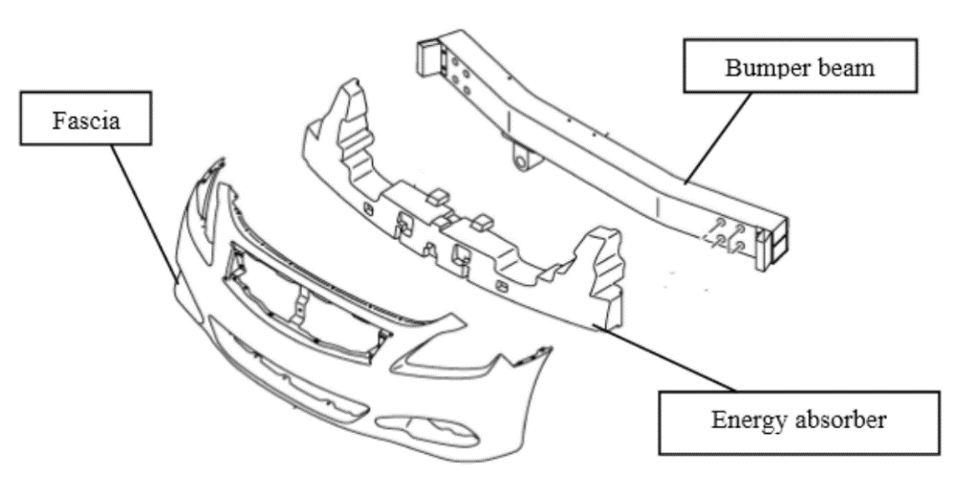
Fig. 1. Main parts of Bumper System [2]

1.4.1 The Fascia: is generally used for reducing the aerodynamic drag force and aesthetics. It cannot sustain to impact energy,there for it is considered as a component non-structural type.
1.4.2 The Energy Absorber: is a damping part designed to damp the force created when two cars collide. Traditional energy absorbers often consist of an integrated structure made of foamed polypropylene (EPP) or thermoplastic polymer, which may require a complete overhaul as a result of a home damage.[3]
1.4.3 The Bumper Beam: is a main structure part which helps to absorbing the kinetic energy through a high-speed impact collision and in a low-speed impact collision provide resistance to bending. Bumper beam part will absorb the energy of the impact collision in a controlled manner before it transferred to the occupants.[2]

1.5 Standards to Test the Performance of Vehicle Bumpers
There are several standards that are used to test the performance of vehicle bumpers. These standards are designed to ensure that bumpers are able to protect the vehicle and its occupants in the event of a low-speed collision. [6]

1.5.1 FMVSS
NHTSA (National Highway Traffic Safety Administration) issues Federal Motor Vehicle Safety Standards (FMVSS) to implement laws from Congress in united states. It has made it a top goal to decrease the number of deaths and the severity of injuries caused by forceful air bag deployment in low-speed collisions while also maintaining the advantages for adults who are generally seated, restrained, and wearing seatbelts in high severity crashes.These regulations allow to fulfil the mission to prevent and reduce vehicle crashes. One common standard for bumper testing is the FMVSS No. 208, which is used in the United States to test the performance of vehicle bumpers. This standard specifies requirements for the energy absorption and deflection of bumpers, as well as requirements for the strength and attachment of bumper components. [7]

Overview of Potential Candidate Test Procedures

1.5.1.1 Full Frontal Fixed Barrier:
The full-frontal Fixed Barrier Crash test (also known as the Rigid Barrier test) simulates a collision between two vehicles traveling at the same speed when they collide. Figure (1-2) displays a schematic of the test arrangement. The test is made to mimic the majority of real crashes involving a significant amount of frontal contact in the direction of impact (both car-to-car and car-to-fixed object incidents). The barrier rebound velocity for FMVSS No. 208 typically ranges up to 10% of the impact velocity for a change in velocity of up to 53 kph, though it does vary slightly from vehicle to vehicle. The impact velocity ranges from 0 to 48 kmph (0 to 30 mph) for this standard. [7]
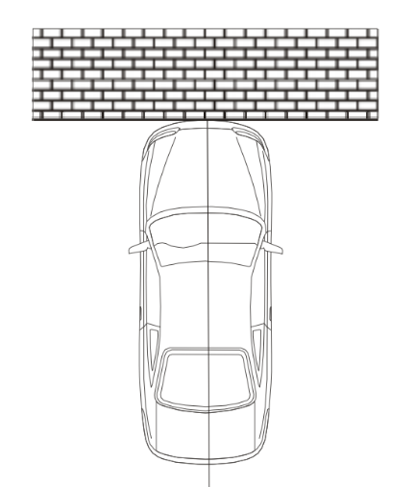
Fig. 2. Full Frontal Fixed Barrier [7]

1.5.1.2 Oblique Frontal Fixed Barrier
A stiff barrier test at speeds of up to 48 kmph and at angles of up to 30 degrees from the line of travel are required by FMVSS No. 208's frontal barrier crash test. Figure 1-6 displays a schematic of the test arrangement. Oblique frontal fixed barrier tests offer a longer length crash pulse with a lower acceleration than full-frontal fixed barrier tests. [7]
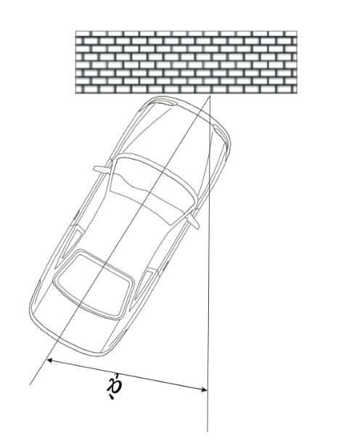
Fig. 3. Oblique Frontal Fixed Barrier (shown at 30º Impact Angle) [7]

1.5.1.4 Frontal Fixed Offset Deformable Barrier:
This test, also known as the Offset Barrier Test, involves partially engaging the front structure of the vehicle/occupant restraint system with a crushable barrier face. The offset barrier test generates what is often referred to as a "soft" crash pulse, which has a lower acceleration and a longer duration than the complete frontal fixed rigid barrier test. It is a whole systems test that assesses how the occupant restraint system and the energy-absorbing vehicle structure react to a low severity collision pulse. With reduced frontal contact and perpendicular hits with changes in speed up to about 56–60 kmph based upon a speed of impact 56 kmph, the offset barrier test is designed to simulate the majority of real-world accidents.

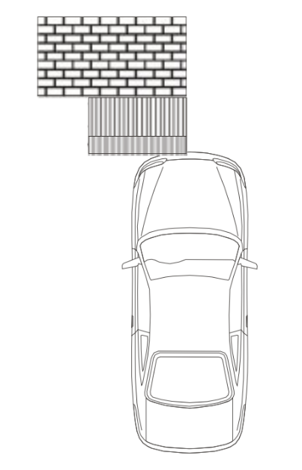
Fig. 4. Frontal 40 % Offset Deformable Barrier Test[7]

1.5.1.5 Oblique Moving Deformable Barrier Test (MDB)
This test is designed to simulate extremely serious oblique accidents with extensive frontal contact and intrusion. The frontal-oblique MDB test results in a short-duration, high-deceleration crash pulse that is commonly referred to as a "stiff" pulse. The test is designed to replicate an oblique car-to-car collision with each travelling at 50 to 60 kph or with only one going at 100 to 120 kph. [7]
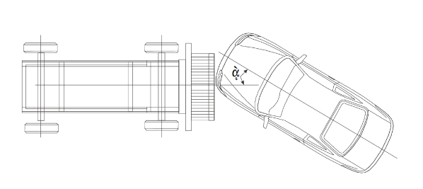
Fig. 5. Oblique Moving Deformable Barrier (MDB) Test

1.5.1.6 Full Frontal Fixed Deformable-face Barrier (FFFDB)
In order to fully engage the vehicle construction, the Full Frontal Fixed Deformable-face Barrier (FFFDB) test expands on the Deformable Offset Barrier Test's basic idea. A car is pressed up against an experiment's stiff, flexible wall. Fully engaged is the vehicle's front structure. Although the rebound speed changes from car to car and is typically ten percent of the velocity of impact, it should be noted that the change in speed during this test is about the same for belted or unbelted passengers, ranging from 0 to 53 kph. [7]
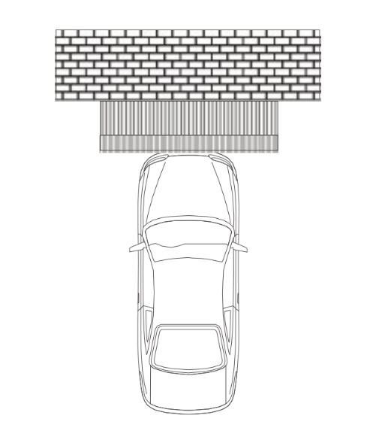

Fig. 6. Full Frontal Fixed Deformable-face Barrier (FFFDB)

1.5.2 RCAR Bumper Test Protocol
RCAR (Research Council for Automobile Repair) is a global organization of vehicle research facilities run or controlled by insurance companies or groupings of insurance companies, with the main objective of advancing the RCAR purpose. The RCAR Bumper Test pushes automakers to design efficient bumper systems with high energy absorption beams and crash boxes that can successfully shield the car in low-speed collisions. Additionally, the bumper systems must feature broad beams that shield the car’s corners from low-speed collisions. According to RCAR, good vehicle bumper beams should include the following characteristics:
Can be mounted on cars' front and back.
- have a beam height larger than 100 mm and be positioned to engage properly with the front and back bumper barriers. - be interchangeable without cutting or welding.
- maintain stability throughout impacts to avoid underride and override
- be able to carry lateral loads without twisting by being torsion-resistant.
- deflect energy and restrict harm to the bumper system alone.
- be joined to the body using components that absorb energy and are simple to replace or repair.
Protect expensive structural, welded, or bonded, and other parts from harm.
- stretch laterally to safeguard the car's corners.To determine how successfully a vehicle’s bumper system shields it from harm in low-speed accidents, an international RCAR working group has devised test methodologies. These studies address three aspects of bumper function while producing damage that closely resembles the patterns seen in low-speed collisions in the real world.
1. Geometry – In order to appropriately contact other cars in low-speed collisions, vehicle bumpers must be positioned at standard heights above the ground and extend laterally to the corners.
2. Stability – Vehicle bumpers must be sufficiently tall and broad to maintain contact with the bumpers of other cars even while the moving vehicle is being loaded, stopping, etc.
3. Energy-absorption – Bumpers on vehicles should deflect low-speed accident energy without causing harm to other car components.[8]

1.10.2.1 Full-width Tests:
During collision, the center of the bumper barrier will be parallel to the centerline of the vehicle. The degree of lateral deviation that is permissible will be decided by each test houses due to the variations in automotive propulsion systems. The majority of the time, lateral variations up to and including 50 mm are acceptable. Impact will occur at a speed of 10.0 kph.
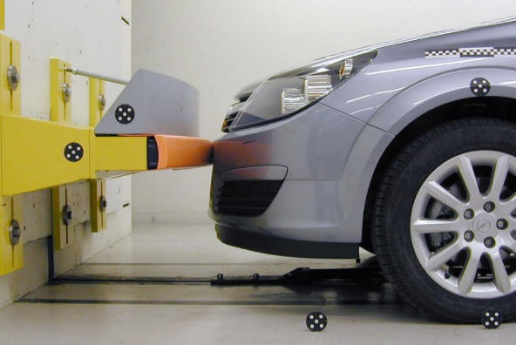
Fig. 7. Full width test

1.5.2.2 Corner Test
Figure shows how the width of the vehicle, as estimated at the wheel wells (including frames and sheet metal protrusions) at the relevant axle—the front axle for the front corner tests—must exceed the lateral edge of the wall by 15% of the car's width after impact (1-8). A 5.0 kph impact speed is required.

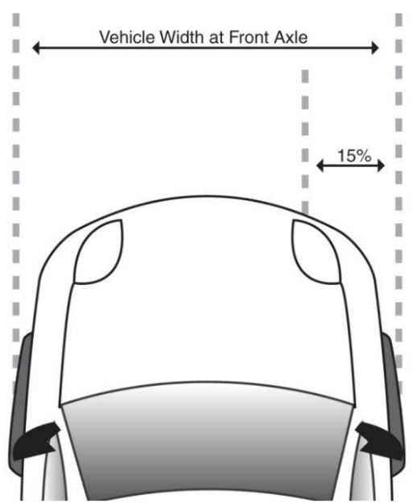

Fig. 9. 15 Percent Overlap Based on Vehicle Width at Front Axle Measured at Wheel Wells

1.5.3 ISO
The ISO (International Organization for Standardization) is a non-governmental organization that creates and disseminates worldwide standards, some of which are used to evaluate how well car bumper’s function., the EU (European Union) Directive on General Safety of Motor Vehicles, these standards include.
- ISO 6603-2: "Road vehicles -- Low-speed frontal impact test procedure -- Part 2: Passenger cars"
- ISO 6603-3: "Road vehicles -- Low-speed frontal impact test procedure -- Part 3: Light commercial vehicles"
These standards specify the procedures and requirements for testing the performance of vehicle bumpers, including requirements for the strength and attachment of bumper components, and the energy absorption and deflection of bumpers during a collision. These standards are intended to ensure that bumpers are able to effectively protect vehicles and their occupants in the event of a low-speed collision. [9]

1.5.4 EURO NCAP
The Euro NCAP (EUROPEAN NEW CAR ASSESSMENT PROGRAMME) is a program that is employed to assess how well new cars perform in terms of safety. It is administered by the European New Car Assessment Programme in Europe.
As part of the NCAP testing process, vehicles are subjected to several different crash tests, including a front impact test and a side impact test. These tests are designed to simulate the kinds of crashes that vehicles are likely to experience in real-world situations, and they are used to measure the performance of various safety systems, such as seat belts, airbags, and bumpers.
The NCAP program also includes to make evaluation for a new car test conducted at 56 kmph hit The front of the barrier is made up of a reinforced concrete block that is at least 3 meters wide and 1.5 meters high. The barrier must be at least 70 metric tons thick and weigh that much in weight. The front face must be level, vertical, and orthogonal to the run-up track's axis. [10]

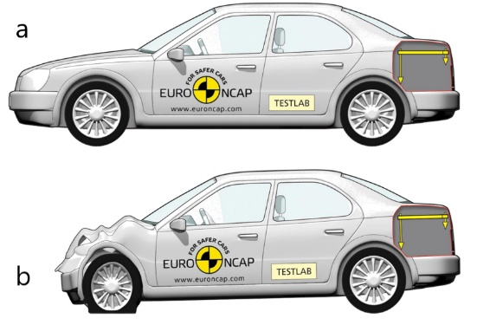
Fig. 10. Euro NCAP Front Test Protocol

1.5.5 IIHS
Reducing the number of collisions is the mission of the Insurance Institute for Highway Safety (IIHS), a non-profit organization, injuries, and fatalities on the nation's roads. The IIHS conducts a variety of research and testing programs to evaluate the safety performance of vehicles, Reducing the amount of collisions is the mission of the Insurance Institute for Highway Safety (IIHS), a non-profit organization. One of the tests that the IIHS conducts as part of its vehicle rating program is the bumper test, which is designed to evaluate the performance of vehicle bumpers in low-speed collisions. The IIHS bumper test includes both a front and a rear impact test, and it measures the amount of damage sustained by the bumper and the underlying structure of the vehicle as a result of the collision. [11]

1.5.6 (ADR)
The Australian Design Rules (ADR). These standards specify requirements for the design, construction, and performance of vehicle bumpers, with the goal of ensuring that bumpers are able to effectively protect vehicles and their occupants in the event of a collision. [12]
1.6 conclusions: from the above there are many standards for manufacturing car bumper to improve the ability of energy absorbing through the collisions, all these efforts are to protect the passengers and driver.
- References
[1] M. M. Davoodi, S. M. Sapuan, D. Ahmad, A. Aidy, A. Khalina, and M. Jonoobi, “Concept selection of car bumper beam with developed hybrid bio-composite material,” Mater Des, vol. 32, no. 10, pp. 4857–4865, Dec. 2011, doi: 10.1016/j.matdes.2011.06.011.
[2] M. Nasiruddin, S. #1, H. A. #2, R. J. #3, W. W. S. #4, and A. M. N. #5, “A Review of Energy Absorption of Automotive Bumper Beam,” 2017. [Online]. Available: http://www.ripublication.com
[3] F. Mo, S. Zhao, C. Yu, Z. Xiao, and S. Duan, “Design of a Conceptual Bumper Energy Absorber Coupling Pedestrian Safety and Low-Speed Impact Requirements,” Appl Bionics Biomech, vol. 2018, 2018, doi: 10.1155/2018/9293454.
[4] A. Swamy, G. v #1, P. Satish, R. #2, M. Manoj, and P. Bhaskar, “Impact Analysis of A Car Bumper Using Carbon Fiber Reinforced PEI And S2 Glass/Epoxy Materials By Solid Works Software,” International Journal of Science Engineering and Advance Technology, IJSEAT, vol. 2, no. 10, 2014, [Online]. Available: www.ijseat.com
[5] M. M. Davoodi, S. M. Sapuan, and R. Yunus, “Conceptual design of a polymer composite automotive bumper energy absorber,” Mater Des, vol. 29, no. 7, pp. 1447–1452, 2008, doi: 10.1016/j.matdes.2007.07.011.
[6] A. T. Beyene, E. G. Koricho, G. Belingardi, and B. Martorana, “Design and manufacturing issues in the development of lightweight solution for a vehicle frontal bumper,” in Procedia Engineering, 2014, vol. 88, pp. 77–84. doi: 10.1016/j.proeng.2014.11.129.
[7] National highway traffic safety administration organization, https://www.nhtsa.gov/
[8] Research Council for Automobile Repair https://www.rcar.org/ Issue 2.2 February 2020
[9] International Organization for Standardization https://www.iso.org/standard
[10] European new car assessment program https://www.euroncap.com/en ,Version 1.0.2,2015
[11] The Insurance Institute for Highway Safety organization https://www.iihs.org/
[12] The Australian design rules organization https://www.infrastructure.gov.au/

